Adams Township is now accepting

Snow Removal Bids for 2022/2023.

**We need bids for the following locations:**

1. Township office at 201 S. Main St., Sheridan, Indiana
2. Community Building located at 111 W. 296th St, Atlanta, IN (Ekin)

If you are interested, please drop off a bid at the Adams Township Trustee’s Office, 201 S. Main Street, Sheridan, IN, 46069 by October 20, 2022.

For more information contact Michelle Junkins at (317)758-1029

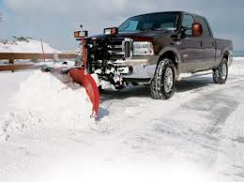

**Snow Removal Bids**

SnowflakesSnowflakes