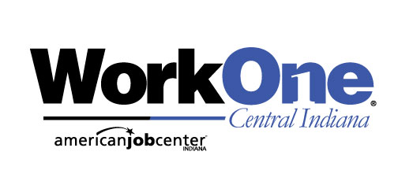

Week of November 27, 2023
www.IndianaCareerConnect.com
Toshiba America Business  Job #: 10527079  Job Title: Managed Print Sales | Follow us on Twitter  @NoblesvilleW1 | Apex Systems, Inc  Job #: 10525013  Job Title: Project Manager
Center For Diagnostic Imaging  Job #: 10526406  Job Title: Radiologic Technologist | Muzak  Job #: 10526265  Job Title: National Sales Director | Convergint Technologies, LLC  Job #: 10525519  Job Title: Procurement Data Specialist
Horizon Bank  Job #: 10524960  Job Title: Credit Analyst II | ResCare  Job #: 10525576  Job Title: DIRECT SUPPORT PROFESSIONAL | ResCare  Job #: 10524733  Job Title: PROGRAM MANAGER
Apex Systems, Inc  Job #: 10525937  Job Title: Hybrid Sr. Product Designer | Eagle Care LLC  Job #: 10525974  Job Title: LPN- Licensed Practical Nurse | Cushman & Wakefield National  Job #: 10525724  Job Title: Maintenance Technician Multifamily
Trilogy Health Services  Job #: 10526778  Job Title: Assistant Director of Nursing | Performance Contracting, Inc.  Job #: 10526784  Job Title: Regional Craft Employment -Great Lakes Region | Hanger Prosthetics & Orthotics  Job #: 10526010  Job Title: Prosthetist Orthotist or Prosthetist Clinician
Delta Faucet Company  Job #: 10524354  Job Title: Automation Engineer | Sunbelt Rentals  Job #: 10526947  Job Title: Mechanic 2 | Sherwin-Williams Company  Job #: 10526977  Job Title: Delivery Driver
Convergint Technologies, LLC  Job #: 10524491  Job Title: Security Technician 2 | Trinity Services Group  Job #: 10525130  Job Title: Picking | Edward D. Jones  Job #: 10524438  Job Title: Associate Financial Advisor - Fishers, IN
Facility Solutions Group Inc.  Job #: 10525051  Job Title: Administrative Assistant (Indianapolis) | Follow us on Twitter  @HamiltonCoW1 | TruGreen Limited Partnership  Job #: 10524668  Job Title: Customer Service Representative

WorkOne/WIOA Title 1 provides equal opportunity programs. Auxiliary aids and services are available upon request to
individuals with disabilities. The Hearing-Impaired Relay Service is available at: 1-800-743-3333

